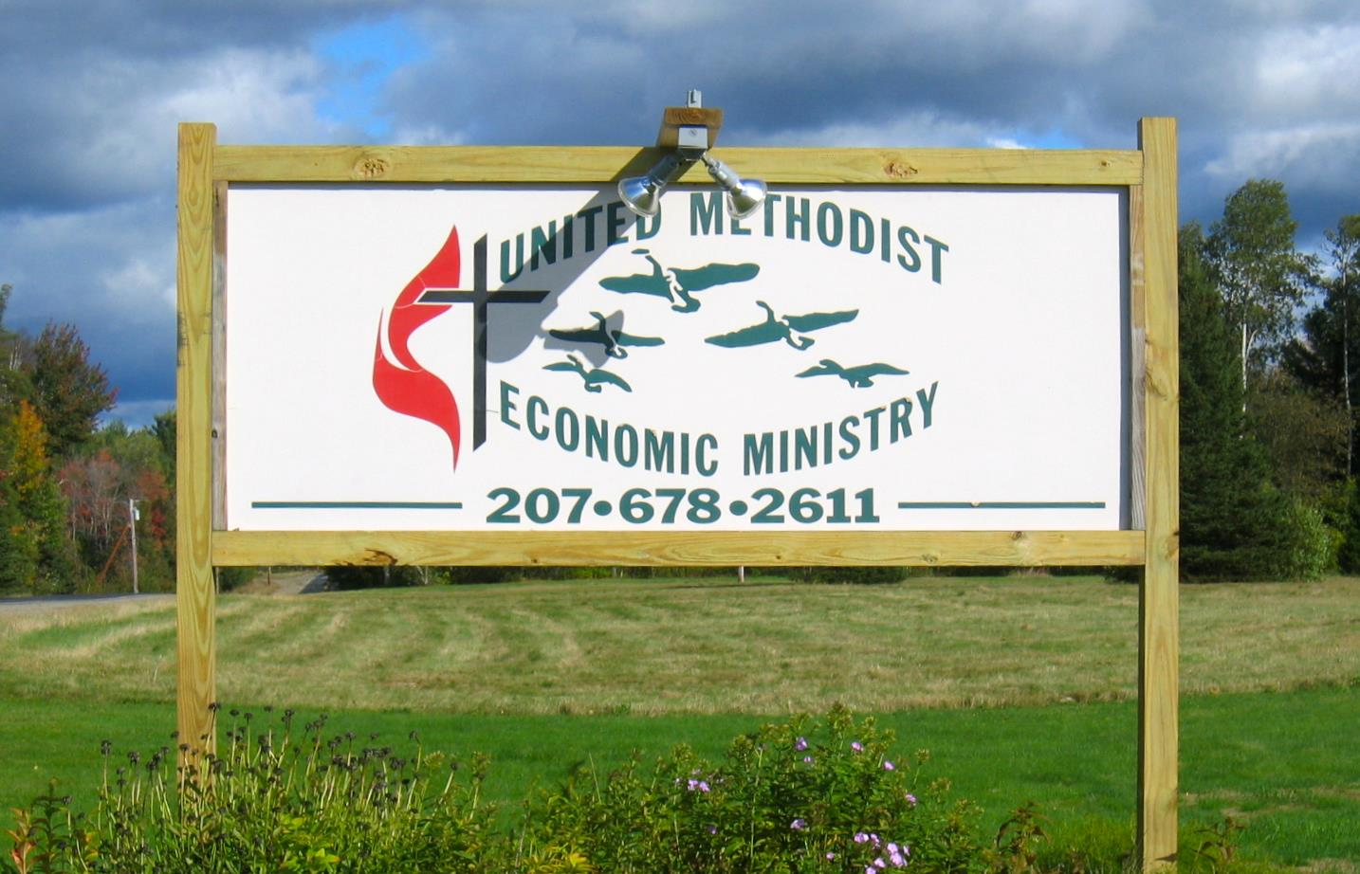

UMEM Board Member Agreement

I, _____________________________, as a member of the United Methodist Economic Ministry Board of Directors, understand I have a legal and ethical responsibility to ensure UMEM does the best work possible in pursuit of its goals. I believe in the purpose and the mission of UMEM, and I will act responsibly and prudently as its steward.

**As part of my responsibilities as a board member:**

I understand Board members are responsible for the health and well-being of the board and UMEM as an organization. I am aware of my legal, ethical and fiduciary responsibilities for the UMEM and those held by my fellow board members. I am responsible for adherence to legal standards and ethical norms and knowledge and oversight of the implementation of UMEM policies and programs. I will act in the best interests of the UMEM, and excuse myself from discussions and votes where I have a conflict of interest.

I will stay informed about what's going on in the organization and seek opportunities to understand the UMEM, its context and the experiences of the people we serve. I will ask questions and request information. I will participate in and take responsibility for making decisions on issues, policies and other board matters.

The Board’s responsibility includes supporting the Executive Director’s strategies for monitoring and strengthening programs and services, as well as determining which programs are consistent with the UMEM mission and monitoring their effectiveness. I will encourage and support UMEM staff through the Executive Director. I will work in good faith with staff and other board members as partners towards achievement of our goals. The Board will reach consensus on the Executive Director’s responsibilities and when needed, undertake a careful search to find the most qualified individual for the position. The Board will ensure the Executive Director has spiritual and professional support to further UMEM goals.

The Board’s responsibility is to maintain and periodically review a statement of mission and purpose to communicate the goals of the organization. We will enhance the organization’s reputation by clearly articulating the organization’s mission, accomplishments, and goals to the New England Conference of the United Methodist Church and to the general public to garner support from those communities. I will actively promote UMEM, I will interpret the organization's work and values to my congregation and the community, represent the organization and act as a spokesperson.

I will attend at least 75% of all board meetings and special events, be available for phone consultation, and serve on at least one UMEM committee. The Board of Directors, working with the Executive Director will, as needed and approved by the Board, establish and make sub-committee assignments that further the UMEM goals, mission and vision for ministry.

The UMEM Board has a responsibility to articulate prerequisites for Board of Director’s candidates, orient new Board members, and periodically and comprehensively evaluate our own performance.

One of the Board’s foremost responsibilities is to secure adequate monetary resources for UMEM to fulfill its mission. I am fiscally responsible, with other board members, for the organization. I will know what our budget is and take an active part in reviewing, approving, and monitoring the budget and fundraising to meet it.

Each year I will make a personal financial contribution that is meaningful to me. I may give this as an annual onetime donation or I may pledge to give a certain amount several times during the year. I will actively engage in fundraising for UMEM as well as other types of service in whatever ways are best suited for me. These may include individual solicitations, undertaking special events, presentations, writing mail appeals and other activities. I will also seek and facilitation in-kind donations to support UMEM ministries.

If I don't fulfill these commitments to the organization, I will expect the board Chair to call me and discuss my responsibilities. If I am not able to meet my obligations as a board member, I will offer my resignation.

**In turn, the UMEM will be responsible to me in the following ways.**

Board members and staff will respond in a straightforward fashion to questions that are necessary to carry out the fiscal, legal, Gospel mandated and ethical responsibilities of the UMEM.  Board members and staff will work cooperatively in good faith towards achievement of our goals.

UMEM will help me perform my duties by keeping me informed about organizational issues and community needs, and by offering me opportunities for professional development as a board member.

Board members will be sent, without request, quarterly financial reports and an update of organizational activities that allow me to meet the "reasonable" standards of the law.

The Board must actively participate in long range and strategic planning processes and assist in implementing and monitoring the plan’s goals.

If UMEM does not fulfill its commitments to me, I can call on the board chair to discuss UMEM’s responsibilities to me.

In signing this document, I understand every board member is making a statement of faith personally and corporately. We trust each other to carry out the above agreement to the best of our ability.

I am a member of the following Committees:  _________________________________

I confirm that I have read and agree to the covenantal expectations and assignments described in this Agreement.

Signed:_________________________________________________ Date: __________

Name

Chair, Board of Directors ___________________________________ Date: _________

**Board Member Self- Assessment**

|  |  |  |  |  |
| --- | --- | --- | --- | --- |
| Area of Responsibility | Very Well | Sufficiently | Partially | Needs Attention |
| Understand legal, ethical and fiduciary responsibilities |  |  |  |  |
| Knowledge of policies and programs |  |  |  |  |
| Understand conflicts of interest |  |  |  |  |
| Understand ministry and clients/context |  |  |  |  |
| Able to participate in decisions |  |  |  |  |
| Clear about Exec Dir role/responsibilities |  |  |  |  |
| Clear about relationship to other staff |  |  |  |  |
| Understand mission, purpose, goals |  |  |  |  |
| Able to promote UMEM |  |  |  |  |
| Have plans to promote and publicize UMEM ministries in our context |  |  |  |  |
| Know Meeting attendance expectations |  |  |  |  |
| Knowledge of UMEM financial resources |  |  |  |  |
| Know personal contribution expectations |  |  |  |  |
| Understand strategic plan and visions for the future |  |  |  |  |
| Have reviewed the Board Manual and UMEM policies documents |  |  |  |  |

1. What resources or changes would strengthen your work as a UMEM Board member?

1. What has been most helpful to you in your role as a UMEM Board member?

1. Share a testimonial about your experience as a UMEM Board member.